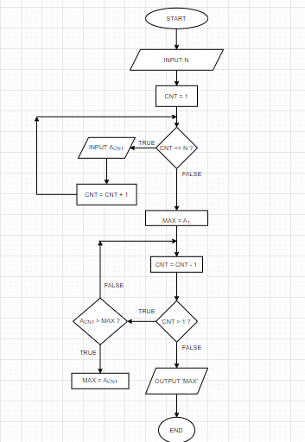

*START*

*INPUT N*

*CNT = 1*

*WHILE (CNT <= N)*

*DO*

*INPUT ACNT*

*CNT = CNT + 1*

*ENDDO*

*MAX = A1*

*CNT = CNT – 1*

*WHILE (CNT > 1)*

*DO*

*IF (ACNT > MAX) THEN*

*MAX = ACNT*

*ENDIF*

*CNT = CNT – 1*

*ENDDO*

*PRINT ‘MAX’*

*END*